UNIT-4
What is a Servlet?
Servlet can be described in many ways, depending on the context.
- Servlet is a technology which is used to create a web application.
- Servlet is an API that provides many interfaces and classes including documentation.
- Servlet is an interface that must be implemented for creating any Servlet.
- Servlet is a class that extends the capabilities of the servers and responds to the incoming requests. It can respond to any requests.
- Servlet is a web component that is deployed on the server to create a dynamic web page.
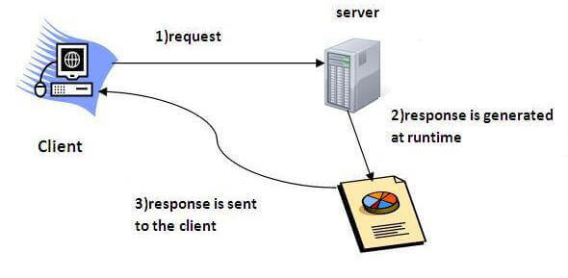
Execution of Servlets basically involves six basic steps:
- The clients send the request to the webserver.
- The web server receives the request.
- The web server passes the request to the corresponding servlet.
- The servlet processes the request and generates the response in the form of output.
- The servlet sends the response back to the webserver.
- The web server sends the response back to the client and the client browser displays it on the screen.

The web container creates threads for handling the multiple requests to the Servlet. Threads have many benefits over the Processes such as they share a common memory area, lightweight, cost of communication between the threads are low. The advantages of Servlet are as follows:
- Better performance: because it creates a thread for each request, not process.
- Portability: because it uses Java language.
- Robust: JVM manages Servlets, so we don't need to worry about the memory leak, garbage collection, etc.
- Secure: because it uses java language.

Servlet API
The javax.servlet and javax.servlet.http packages represent interfaces and classes for servlet api.
The javax.servlet package contains many interfaces and classes that are used by the servlet or web container.
The javax.servlet.http package contains interfaces and classes that are responsible for http requests only.
Servlets API’s:
Servlets are build from two packages:
- javax.servlet(Basic)
- javax.servlet.http(Advance)
Various classes and interfaces present in these packages are:
Component | Type | Package
Servlet | Interface | javax.servlet.*
ServletRequest | Interface | javax.servlet.*
ServletResponse | Interface | javax.servlet.*
GenericServlet | Class | javax.servlet.*
HttpServlet | Class | javax.servlet.http.*
HttpServletRequest | Interface | javax.servlet.http.*
HttpServletResponse | Interface | javax.servlet.http.*
Filter | Interface | javax.servlet.*
ServletConfig | Interface | javax.servlet.*

Web container:
A web container is the component of a web server that interacts with Java servlets. A web container manages the life cycle of servlets; it maps a URL to a particular servlet while ensuring that the requester has relevant access-rights.
The web container implements the web component aspect of the Java engineering architecture; it specifies a run time environment for various components such as security, concurrency, transaction, and deployment.
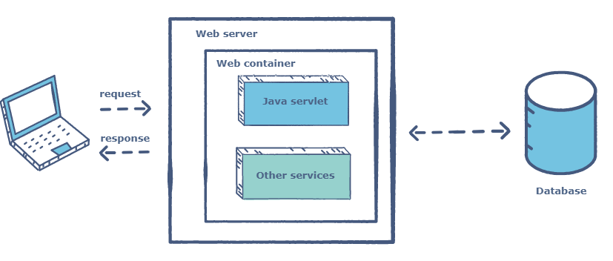

Java servlets do not have a defined main() method, so a web container is required to load them. The servlet gets deployed on the container.
Let’s have a look at what happens when a client sends a certain request that requires interaction with the servlet:
- The client sends a request to a web server.
- The web server, which contains a servlet, sends that request to the container.
- The container passes the request to the respective servlet.
- The servlet methods are loaded.
- The servlet hands over the relevant response to the container, which passes it to the server. Eventually, the response reaches the client.

Servlet Life Cycle
There are three life cycle methods of a Servlet :
- init()
- service()
- destroy()
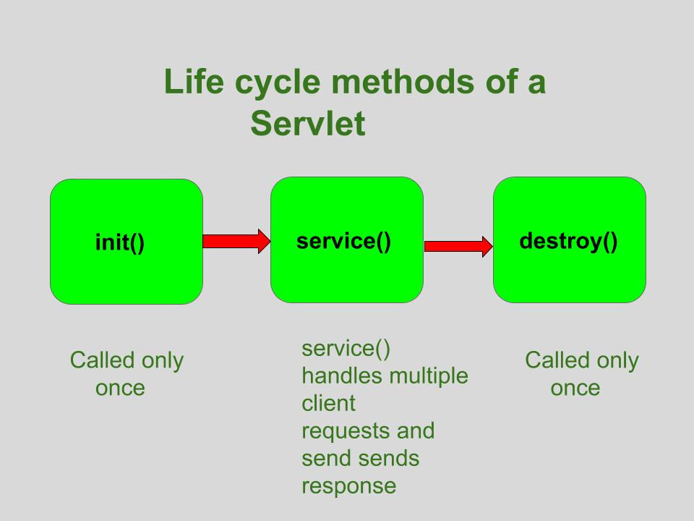

init()
The Servlet.init() method is called by the Servlet container to indicate that this Servlet instance is instantiated successfully and is about to put into service.
//init() method
public class MyServlet implements Servlet{
public void init(ServletConfig config) throws ServletException {
//initialization code
}
//rest of code
}
service():
The service() method of the Servlet is invoked to inform the Servlet about the client requests.
- This method uses ServletRequest object to collect the data requested by the client.
- This method uses ServletResponse object to generate the output content.
// service() method
public class MyServlet implements Servlet{
public void service(ServletRequest res, ServletResponse res)
throws ServletException, IOException {
// request handling code
}
// rest of code
}
destroy():
The destroy() method runs only once during the lifetime of a Servlet and signals the end of the Servlet instance.
//destroy() method
public void destroy()
As soon as the destroy() method is activated, the Servlet container releases the Servlet instance.

Writing Servlet Programs
To get started with Servlets, let’s first start with a simple Servlet application i.e LifeCycle application, that will demonstrate the implementation of the init(), service() and destroy() methods.
First of all it is important to understand that if we are developing any Servlet application, it will handle some client’s request so, whenever we talk about Servlets we need to develop a index.html page (can be any other name also) which will request a particular Servlet to handle the request made by the client (in this case index.html page).
To be simple, lets first describe the steps to develop the LifeCycle application :
- Creating the index.html page
- Creating the LifeCycle Servlet
- Creating deployment descriptor

Creating the index.html page
For the sake of simplicity, this page will just have a button invoke life cycle. When you will click this button it will call LifeCycleServlet (which is mapped according to the entry in web.xml file).
<html>
<form action="LifeCycleServlet">
<input type="submit" value="invoke life cycle servlet">
</form>
</html>
The name of the Servlet is given in action attribute of form tag to which the request will be send on clicking the button, in this case FirstServlet.
Creating the Servlet (FirstServlet)
Now, its time to create the LifeCycleServlet which implements init(), service() and destroy() methods to demonstrate the lifecycle of a Servlet.
// importing the javax.servlet package
// importing java.io package for PrintWriter
import javax.servlet.*;
import java.io.*;
// now creating a servlet by implementing Servlet interface
public class LifeCycleServlet implements Servlet {
ServletConfig config = null;
// init method
| public void init(ServletConfig sc)
{
config = sc;
System.out.println("in init");
}
// service method
public void service(ServletRequest req, ServletResponse res)
throws ServletException, IOException
{
res.setContentType("text/html");
PrintWriter pw = res.getWriter();
pw.println("<h2>hello from life cycle servlet</h2>");
System.out.println("in service");
}
// destroy method
public void destroy()
{
System.out.println("in destroy");
}
public String getServletInfo()
{
return "LifeCycleServlet";
}
public ServletConfig getServletConfig()
{
return config; // getServletConfig
}
}
Output:
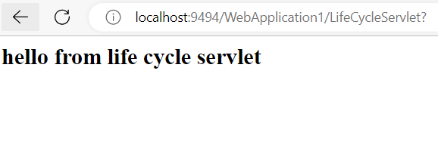

- Write a Servlet Program to Print Swastik College 10 times.
- Write a Servlet Program to Print Tribhuvan University;
Reading Form Parameters:
GET Method
The GET method sends the encoded user information appended to the page request. The page and the encoded information are separated by the ? (question mark) symbol as follow
localhost:9494/ReadingParameterExample/getParameterExample?name=Sunil+Chaudhary&location=Tinkune%2C+Kathmandu&Submit=Submit
The GET method is the default method to pass information from browser to web server and it produces a long string that appears in your browser's Location:box. Never use the GET method if you have password or other sensitive information to pass to the server. The GET method has size limitation: only 1024 characters can be used in a request string.
This information is passed using header and will be accessible through QUERY_STRING environment QUERY_STRING variable and Servlet handles this type of requests using doGet() method.
POST Method
A generally more reliable method of passing information to a backend program is the POST method. This packages the information in exactly the same way as GET method, but instead of sending it as a text string after a ? (question mark) in the URL it sends it as a separate message. This message comes to the backend program in the form of the standard input which you can parse and use for your processing. Servlet handles this type of requests using doPost() method.

Reading Form Data using Servlet
Servlets handles form data parsing automatically using the following methods depending on the situation −
- getParameter() − You call request.getParameter() method to get the value of a form parameter.
- getParameterValues() − Call this method if the parameter appears more than once and returns multiple values, for example checkbox.
- getParameterNames() − Call this method if you want a complete list of all parameters in the current request.
GET METHOD EXAMPLE:
Index.html
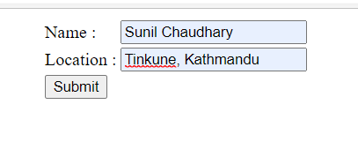
HTML: Code
<html>
<head>
<title>TODO supply a title</title>
<meta charset="UTF-8">
<meta name="viewport" content="width=device-width, initial-scale=1.0">
</head>
<body>
<form method="GET" action="getParameterExample">
<table align="center">
<tr>
<td>Name : </td>
<td><input type="text" name="name"/></td>
</tr>
<tr>
<td>Location : </td>
<td><input type="text" name="location"/></td>
</tr>
<tr>
<td colspan="2"><input type="submit" name="Submit" value="Submit"/></td> </tr>
</table>
</form>
</body>
|</html>

Servlet File(getParameterExample.java)
protected void processRequest(HttpServletRequest request, HttpServletResponse response)
throws ServletException, IOException {
response.setContentType("text/html;charset=UTF-8");
try (
PrintWriter out = response.getWriter()) {
out.println("<!DOCTYPE html>");
out.println("<html>");
out.println("<head>");
out.println("<title>Servlet getParameterExample</title>");
out.println("</head>");
out.println("<body>");
out.println("<h1>Servlet getParameterExample at " + request.getContextPath() + "</h1>");
out.println("<ul>");
out.println("<li>"+request.getParameter("name")+"</li");
out.println("<li>"+request.getParameter("location")+"</li");
out.println("</ul>");
out.println("</body>");
out.println("</html>");
}
}
protected void doGet(HttpServletRequest request, HttpServletResponse response)
throws ServletException, IOException {
processRequest(request, response);
}
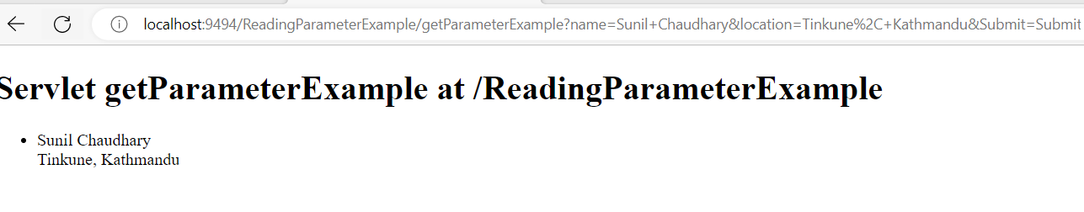

POST Method Example Using Form:
Similar to Get Method:
<form method="POST" action="getParameterExample">
<table align="center">
<tr>
<td>Name : </td>
<td><input type="text" name="name"/></td>
</tr>
<tr>
<td>Location : </td>
<td><input type="text" name="location"/></td>
</tr>
<tr>
<td colspan="2"><input type="submit" name="Submit" value="Submit"/></td>
</tr>
</table>
</form>

Servlet File(getParameterExample.java)
protected void processRequest(HttpServletRequest request, HttpServletResponse response)
throws ServletException, IOException {
response.setContentType("text/html;charset=UTF-8");
try (
PrintWriter out = response.getWriter()) {
out.println("<!DOCTYPE html>");
out.println("<html>");
out.println("<head>");
out.println("<title>Servlet getParameterExample</title>");
out.println("</head>");
out.println("<body>");
out.println("<h1>Servlet getParameterExample at " + request.getContextPath() + "</h1>");
out.println("<ul>");
out.println("<li>"+request.getParameter("name")+"</li");
out.println("<li>"+request.getParameter("location")+"</li");
out.println("</ul>");

out.println("</body>");
out.println("</html>");
}
}
protected void doPost(HttpServletRequest request, HttpServletResponse response)
throws ServletException, IOException {
processRequest(request, response);

}
DataAccess In Servlet
Index.html
<form method="POST" action="DataAccssController">
<table align="center">
<tr>
<td>ID : </td>
<td><input type="text" name="id"/></td>
</tr>
<tr>
<td>Name : </td>
<td><input type="text" name="name"/></td>
</tr>
<tr>
<td>Email : </td>
<td><input type="text" name="email"/></td>
</tr>
<tr>
<td>Address : </td>
<td><input type="text" name="address"/></td>
</tr>
<tr>

<td colspan="2"><input type="submit" name="Submit" value="Submit"/></td>
</tr>
</table>
</form>
DataAccessController(Servlet)
protected void processRequest(HttpServletRequest request, HttpServletResponse response)
throws ServletException, IOException, ClassNotFoundException {
try{
Class.forName("com.mysql.jdbc.Driver");
Connection con=DriverManager.getConnection("jdbc:mysql://localhost:3306/samriddhidb","root","root");
String sql="insert into emp(ID,Name,Email,Address) values(?,?,?,?)";
PreparedStatement ps = con.prepareStatement(sql);

ps.setInt(1,Integer.valueOf(request.getParameter("id")));
ps.setString(2, request.getParameter("name"));
ps.setString(3, request.getParameter("email"));
ps.setString(4, request.getParameter("address"));
ps.executeUpdate();
con.close();
PrintWriter out = response.getWriter();
out.println("<html><body><b>Successfully Inserted" + "</b></body></html>");
}
catch(SQLException ex)
{

}

}

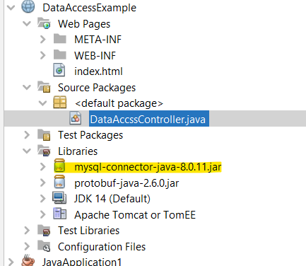
Process to deploy the servlet.
After installing Tomcat Server on your machine follow the below mentioned steps :
- Create directory structure for your application.
- Create a Servlet
- Compile the Servlet
- Create Deployement Descriptor for your application
- Start the server and deploy the application

Cookies in Servlet
A cookie is a small piece of information that is persisted between the multiple client requests.

How Cookie works
By default, each request is considered as a new request. In cookies technique, we add cookie with response from the servlet. So cookie is stored in the cache of the browser. After that if request is sent by the user, cookie is added with request by default. Thus, we recognize the user as the old user.
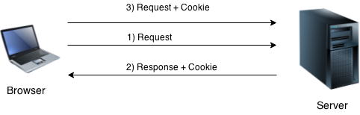

Types of Cookie
here are 2 types of cookies in servlets.
- Non-persistent cookie
- Persistent cookie

Non-persistent cookie
It is valid for single session only. It is removed each time when user closes the browser.

Persistent cookie
It is valid for multiple session . It is not removed each time when user closes the browser. It is removed only if user logout or signout.

Advantage of Cookies
- Simplest technique of maintaining the state.
- Cookies are maintained at client side.

Disadvantage of Cookies
- It will not work if cookie is disabled from the browser.
- Only textual information can be set in Cookie object.

Cookie class
javax.servlet.http.Cookie class provides the functionality of using cookies. It provides a lot of useful methods for cookies.

Constructor of Cookie class
Constructor | Description
Cookie() | constructs a cookie.
Cookie(String name, String value) | constructs a cookie with a specified name and value.

Methods of Cookie
Method | Description
public void setMaxAge(int expiry) | Sets the maximum age of the cookie in seconds.
public String getName() | Returns the name of the cookie. The name cannot be changed after creation.
public String getValue() | Returns the value of the cookie.
public void setName(String name) | changes the name of the cookie.
public void setValue(String value) | changes the value of the cookie.

Example:

Creating cookies
Cookie ck=new Cookie("username","suneel");//creating cookie object
response.addCookie(ck);//adding cookie in the response

Delete Cookies
Cookie ck=new Cookie("username","");//deleting value of cookie
ck.setMaxAge(0);//changing the maximum age to 0 seconds
response.addCookie(ck);//adding cookie in the response

Reading Cookies
Cookie ck[]=request.getCookies();
for(int i=0;i<ck.length;i++){
out.print("<br>"+ck[i].getName()+" "+ck[i].getValue());//printing name and value of cookie
}

Example:

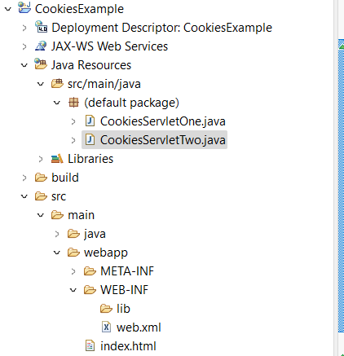

CookiesServletOne.java
import java.io.*;
import javax.servlet.*;
import javax.servlet.annotation.WebServlet;
import javax.servlet.http.*;
@WebServlet("/CookiesServletOne")
public class CookiesServletOne extends HttpServlet {
private static final long serialVersionUID = 1L;

public CookiesServletOne() {
super();

}
protected void doGet(HttpServletRequest request, HttpServletResponse response) throws ServletException, IOException {
try{
response.setContentType("text/html");
PrintWriter pwriter = response.getWriter();

String name = request.getParameter("userName");
String password = request.getParameter("userPassword");
pwriter.print("Hello "+name);
pwriter.print("Your Password is: "+password);

//Creating two cookies
Cookie c1=new Cookie("userName",name);
Cookie c2=new Cookie("userPassword",password);

//Adding the cookies to response header
response.addCookie(c1);
response.addCookie(c2);
pwriter.print("<br><a href='CookiesServletTwo'>View Details</a>");
pwriter.close();
}catch(Exception exp){
System.out.println(exp);
}
}

protected void doPost(HttpServletRequest request, HttpServletResponse response) throws ServletException, IOException {

doGet(request, response);
}

}
CookiesServletTwo.java
import java.io.*;
import javax.servlet.*;
import javax.servlet.annotation.WebServlet;
import javax.servlet.http.*;
@WebServlet("/CookiesServletTwo")
public class CookiesServletTwo extends HttpServlet {
private static final long serialVersionUID = 1L;

public CookiesServletTwo() {
super();

}
protected void doGet(HttpServletRequest request, HttpServletResponse response) throws ServletException, IOException {
try{
response.setContentType("text/html");
PrintWriter pwriter = response.getWriter();

//Reading cookies
Cookie c[]=request.getCookies();
//Displaying User name value from cookie
pwriter.print("Name: "+c[0].getValue());
//Displaying user password value from cookie
pwriter.print("Password: "+c[1].getValue());

pwriter.close();
}catch(Exception exp){
System.out.println(exp);
}
}

protected void doPost(HttpServletRequest request, HttpServletResponse response) throws ServletException, IOException {

doGet(request, response);
}

}
Index.html
<body>
<form action="CookiesServletOne" method="post">
User Name:<input type="text" name="userName"/><br/>
Password:<input type="password" name="userPassword"/><br/>
<input type="submit" value="submit"/>
</form>
</body>
</html>

Design View index.html
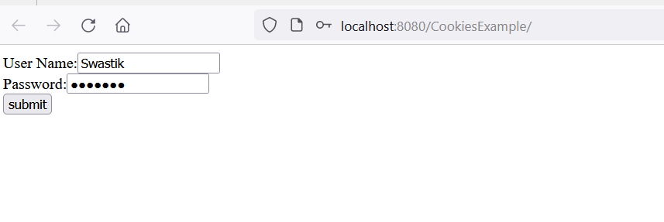

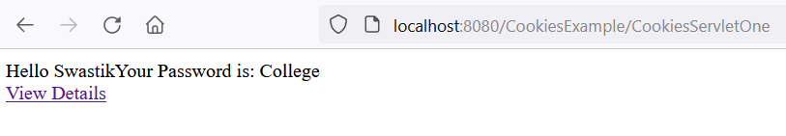
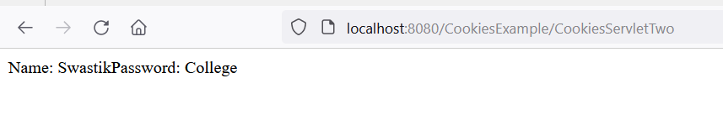

Q. Write a Java program to store “Swastik College” String value in session and retrieve from session using Servlet.

Q. Write a Java program to store Username and Password from two input field in cookies and retrieve value from cookies using Servlet.

HttpSession:
HttpSession is an interface that provides a way to identify a user in multiple page requests. A unique session id is given to the user when first request comes. This id is stored in a request parameter or in a cookie.

How to get session object?
The HttpServletRequest interface provides two methods to get the object of HttpSession:
- public HttpSession getSession():Returns the current session associated with this request, or if the request does not have a session, creates one.
- public HttpSession getSession(boolean create):Returns the current HttpSession associated with this request or, if there is no current session and create is true, returns a new session.
Syntax:
HttpSession session = request.getSession();
HttpSession session = request.getSession(true);

How to set attribute in session object?
HttpSession interface’s setAttribute() method is used to set attribute in session object.
public void setAttribute(String name,Object value);
Example:
session.setAttribute("attName", "attValue");

How to get attribute from session object?
HttpSession interface’s getAttribute() method is used to get attribute from session object.
Syntax:
public Object getAttribute(String name);
Example:
String value = (String) session.getAttribute("attName");

Example of using HttpSession

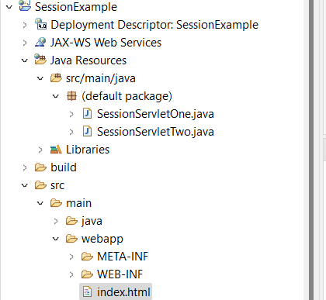

SessionServletOne.Java
import java.io.*;
import javax.servlet.*;
import javax.servlet.annotation.WebServlet;
import javax.servlet.http.*;
@WebServlet("/SessionServletOne")
public class SessionServletOne extends HttpServlet {
private static final long serialVersionUID = 1L;

public SessionServletOne() {
super();

}

protected void doGet(HttpServletRequest request, HttpServletResponse response) throws ServletException, IOException {
try{

response.setContentType("text/html");
PrintWriter out = response.getWriter();

String n=request.getParameter("userName");
out.print("Welcome "+n);

HttpSession session=request.getSession();
session.setAttribute("uname",n);

out.print("<a href='SessionServletTwo'>visit</a>");

out.close();

}catch(Exception e){
System.out.println(e);
}

}

protected void doPost(HttpServletRequest request, HttpServletResponse response) throws ServletException, IOException {

doGet(request, response);
}

}

SessionServletTwo.java
import java.io.*;
import javax.servlet.*;
import javax.servlet.annotation.WebServlet;
import javax.servlet.http.*;

@WebServlet("/SessionServletTwo")
public class SessionServletTwo extends HttpServlet {
private static final long serialVersionUID = 1L;

public SessionServletTwo() {
super();

}

protected void doGet(HttpServletRequest request, HttpServletResponse response) throws ServletException, IOException {
try{

response.setContentType("text/html");
PrintWriter out = response.getWriter();

HttpSession session=request.getSession(false);
String n=(String)session.getAttribute("uname");
out.print("Hello "+n);
out.close();
}catch(Exception e){System.out.println(e);}
}

protected void doPost(HttpServletRequest request, HttpServletResponse response) throws ServletException, IOException {

doGet(request, response);
}

}

index.html
<body>
<form action="SessionServletOne">
Name:<input type="text" name="userName"/><br/>
<input type="submit" value="go"/>
</form>
</body>
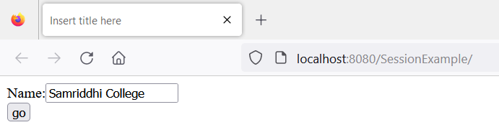
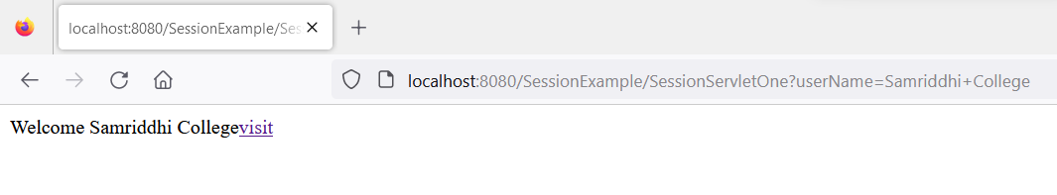
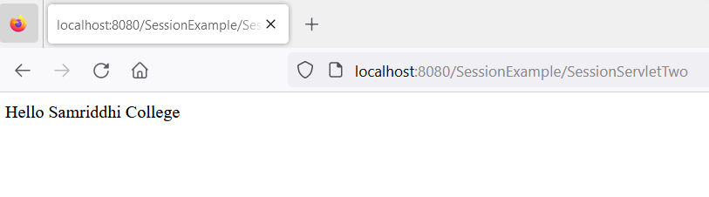

Introduction to JSP
- Jsp (java Server page) is extension of servlet technology but JSP provides more functionality than Servlet
- Fast Development
- Less code
JSP Syntax:
- Declaration Tag :- The declaration tag in JSP (<%! %>) is used to declare variables or methods. These declarations are available throughout the JSP page.
Syntax:-
<%!
//declaration goes here
%>
Example:-
<%!
int counter = 0;
public int incrementCounter() {
return ++counter;
}
%>
- Java Scriplets :- It allows us to add any number of JAVA code with in your HTML, variables and expressions.
Syntax:-
<%
// Java code goes here
%>
Example:-
<%
int number = 10;
out.println("The number is: " + number);
%>
Write a program to Print “IOST” 10 times using jsp.
Lab: WRITE A JSP PROGRAM TO PRINT IOST 10 TIMES.
<%
int i;
for(i = 0; i < 10; i++) {
out.println("Java<br>");
}
%>
- JAVA Comments :- It contains the text that is added for information which has to be ignored.
Syntax:-
<% -- JSP Comments %>
- JSP Declarations
A declaration declares one or more variables or methods that you can use in Java code later in the JSP file. You must declare the variable or method before you use it in the JSP file.
<%! declaration; [ declaration; ]+ ... %>
Example:
<%!
int counter = 0;
public int incrementCounter() {
return ++counter;
}
%>

- JSP Expression
JSP expressions allow you to insert Java code into HTML and output the result directly. The code inside a JSP expression is evaluated and converted to a string.
The expression element can contain any expression that is valid according to the Java Language Specification but you cannot use a semicolon to end an expression.
<%= expression %>
Example:
<%= 2 + 3 %>
Output is 5 which is string
- JSP Directives
A JSP directive affects the overall structure of the servlet class. It usually has the following form −
<%@ directive attribute="value" %>
There are three types of directive tag –
- Page Directive: Defines page settings like content type or import statements.
<%@ page contentType="text/html" %>
<%@ page import="java.util.Date" %>
- Include Directive: Includes content from another file at compile time.
<%@ include file="header.jsp" %>
- Taglib Directive: Declares a custom tag library used in the JSP page.
<%@ taglib prefix="c" uri="http://java.sun.com/jsp/jstl/core" %>
The if...else block starts out like an ordinary Scriptlet, but the Scriptlet is closed at each line with HTML text included between the Scriptlet tags.
<%! int day = 3; %>
<html>
<head><title>IF...ELSE Example</title></head>

<body>
<% if (day == 1 || day == 7) { %>
<p> Today is weekend</p>
<% } else { %>
<p> Today is not weekend</p>
<% } %>
</body>
</html>
Output: Today is not weekend
switch...case block which has been written a bit differentlty using out.println() and inside Scriptletas –
<%! int day = 3; %>
<html>
<head><title>SWITCH...CASE Example</title></head>

<body>
<%
switch(day) {
case 0:
out.println("It\'s Sunday.");
break;
case 1:
out.println("It\'s Monday.");
break;
case 2:
out.println("It\'s Tuesday.");
break;
case 3:
out.println("It\'s Wednesday.");
break;
case 4:
out.println("It\'s Thursday.");
break;
case 5:
out.println("It\'s Friday.");
break;
default:
out.println("It's Saturday.");
}
%>
</body>
</html>
Output: It's Wednesday.
three basic types of looping blocks in Java: for, while, and do…while blocks in your JSP programming.
<%! int fontSize; %>
<html>
<head><title>FOR LOOP Example</title></head>

<body>
<%for ( fontSize = 1; fontSize <= 3; fontSize++){ %>
<font color = "green" size = "<%= fontSize %>">
JSP Tutorial
</font><br />
<%}%>
</body>
</html>
while loop
<%! int fontSize; %>
<html>
<head><title>WHILE LOOP Example</title></head>

<body>
<%while ( fontSize <= 3){ %>
<font color = "green" size = "<%= fontSize %>">
JSP Tutorial
</font><br />
<%fontSize++;%>
<%}%>
</body>
</html>
JSP Form Processing:
Index.jsp
<html>
<body>

<form action = "main.jsp" method = "GET">
First Name: <input type = "text" name = "first_name">
<br />
Last Name: <input type = "text" name = "last_name" />
<input type = "submit" value = "Submit" />
</form>

</body>
</html>
Main.jsp
<html>
<head>
<title>Using GET Method to Read Form Data</title>
</head>

<body>
<h1>Using GET Method to Read Form Data</h1>
<ul>
<li><p><b>First Name:</b>
<%= request.getParameter("first_name")%>
</p></li>
<li><p><b>Last Name:</b>
<%= request.getParameter("last_name")%>
</p></li>
</ul>

</body>
</html>

POST:
<html>
<body>

<form action = "main.jsp" method = "POST">
First Name: <input type = "text" name = "first_name">
<br />
Last Name: <input type = "text" name = "last_name" />
<input type = "submit" value = "Submit" />
</form>

</body>
</html>
Main.jsp
<html>
<head>
<title>Using GET and POST Method to Read Form Data</title>
</head>

<body>
<center>
<h1>Using POST Method to Read Form Data</h1>

<ul>
<li><p><b>First Name:</b>
<%= request.getParameter("first_name")%>
</p></li>
<li><p><b>Last Name:</b>
<%= request.getParameter("last_name")%>
</p></li>
</ul>

</body>
</html>

Exam Asked Question:
Write a program to a JSP web form to take input of a student and submit it to second JSP file which may simply print the values of form submission.
Write a program to a JSP web form to take principle,Time and Rate as input from textfield and calculate it and display Simple interest in second JSP.

Servlet | JSP
Servlets are faster as compared to JSP, as they have a short response time. | JSP is slower than Servlets, as the first step in the JSP lifecycle is the conversion of JSP to Java code and then the compilation of the code.
Servlets are Java-based codes. | JSP are HTML-based codes.
Servlets are harder to code, as here, the HTML codes are written in Java. | JSPs are easier to code, as here Java is coded in HTML.
In an MVC architecture, Servlets act as the controllers. | In MVC architectures, the JSPs act as a view to present the output to the users.
The service() function can be overridden in Servlets. | The service() function cannot be overridden in JSPs.
The Servlets are capable of accepting all types of protocol requests. | The JSPs are confined to accept only the HTTP requests.
Modification in Servlets is a time-consuming and challenging task, as here, one will have to reload, recompile, and then restart the servers. | Modification is easy and faster in JSPs as we just need to refresh the pages.
Servlets require the users to enable the default sessions management explicitly, as Servlets do not provide default session management. | JSPs provide session management by default.
Servlets require us to implement the business logic and presentation logic in the same servlet file. | JSPs give us the flexibility to separate the business logic from the presentation logic using javaBeans.
Servlets can handle general data processing. | JSPs cannot handle data processing functions efficiently.
Servlets do not provide the facility of writing custom tags. | JSPs can provide the facility of building the JSP tags easily, which can directly call javaBeans.
We need to import all the packages at the top of the Servlets. | In JSPs, we can import packages anywhere in the file.

What is Framework in Java
Java Framework is the body or platform of pre-written codes used by Java developers to develop Java applications or web applications. In other words, Java Framework is a collection of predefined classes and functions that is used to process input, manage hardware devices interacts with system software. It acts like a skeleton that helps the developer to develop an application by writing their own code.
What is a framework?
Framework are the bodies that contains the pre-written codes (classes and functions) in which we can add our code to overcome the problem. We can also say that frameworks use programmer's code because the framework is in control of the programmer. We can use the framework by calling its methods, inheritance, and supplying "callbacks", listeners, or other implementations of the Observer pattern.
Some of the most popular Java frameworks are:
- Spring
- Hibernate
- Grails
- Play
- JavaServer Faces (JSF)
- Google Web Toolkit (GWT)
- Quarkus
Spring
It is a light-weighted, powerful Java application development framework. It is used for JEE. Its other modules are Spring Security, Spring MVC, Spring Batch, Spring ORM, Spring Boot and Spring Cloud etc.
Hibernate
Hibernate is ORM (Object-Relation Mapping) framework that allows us establish communication between Java programming language and the RDBMS.
Grails
It is a dynamic framework created by using the Groovy programming language. It is an OOPs language. Its purpose is to enhance the productivity. The syntax of Grails is matched with Java and the code is compiled to JVM. It also works with Java, JEE, Spring and Hibernate.
Play
It is a unique Java framework because it does not follow JEE standards. It follows MVC architecture pattern. It is used when we want to develop highly scalable Java application. Using Play framework, we can develop lightweight and web-friendly Java application for both mobile and desktop.
JavaServer Faces
It stands for JavaServer Faces. It is a component-based UI framework developed by Oracle that is used to build user interfaces for Java-based applications. It follows MVC design pattern. The application developed using JSF has an architecture that defines a distinction
Google Web Toolkit (GWT)
It is an open-source framework that allows developers to write client-side Java code. With the help of GWT, we can rapidly develop complex browse application. The advantages to use GWT is that we can easily develop and debug Ajax application. the product of Google, such as Google AdSense, Blogger are developed using GWT.

